**AMBIT FROND END**

Userlogin.jsp

user login page poora is mai poora design hoa wa hai is mai jsp use hoe wi hai or jstl k kuch tags bhi hai

tiles-defination.xml

Is mai saray template links hoa way hai

view-defination.xml

is mai saray template extend kardia hai

required data for view is provided by preparer and view is get data from preparer.

preparer is responsible for data and property required for view

master.portlet

porlets ko control karta hai

app.controller

is mai saray routes define hai

portletmasterpagectrl

is mai check karay ga jo device trusted hai ya nahi hai agar trusted hogi tw template url return karday ga.

**basetemplate.js**

is file mai post login ka saara code compile hokar ajaata

**appcontroller.js**

state aati means jis par click kia hai phr wo waha sai portletmasterpagectrl ko call kardeta hai

portlet hamara 1 micro fornt end hota hai

portlet hum apni marzi sai uppar neechay karsaktay wo apne pass sorting karleta yai sort of personlization feature hai ambit mai

aaj kal har user demand karta hai k wo apne hisaan sai personalization kar sakay

portlet master page jo k responsible hai agay inject karne k liye

permission id wo portler master mai check karay ga or us permission id k againt portlet preparer mai jakar return karday ga.

Device management par inspect karengay phr network mai jakar dekhengay tw sara data ajayega side menus ka waha jo id arahi us k against hi next screen ka poora data mangwatay hai

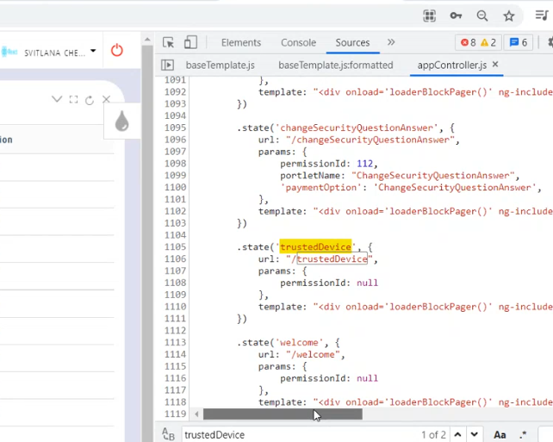

**appcontroller.js**

state aati means jis par click kia hai phr wo waha sai portletmasterpagectrl ko call kardeta hai

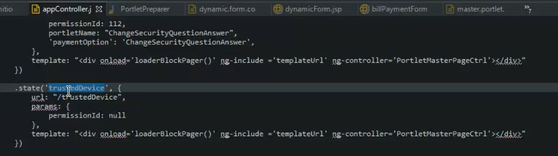

Jb trusted device ki call yaha aati hai tw phr yai **portletmasterpagectrl** ko call karta hai jo k master.portlet k naam sai hoga

Then

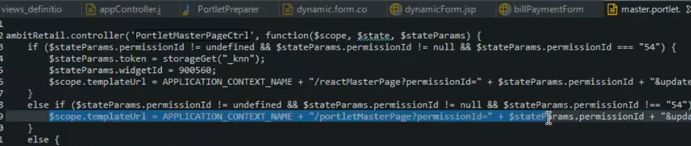

Phr yai line exactly run horahi hoti hai

Is permission id ki base par hum sab sai pehlay apna page load kartay hai or us page k andar kya kya mujood hai wo dekh rahay hotay hai

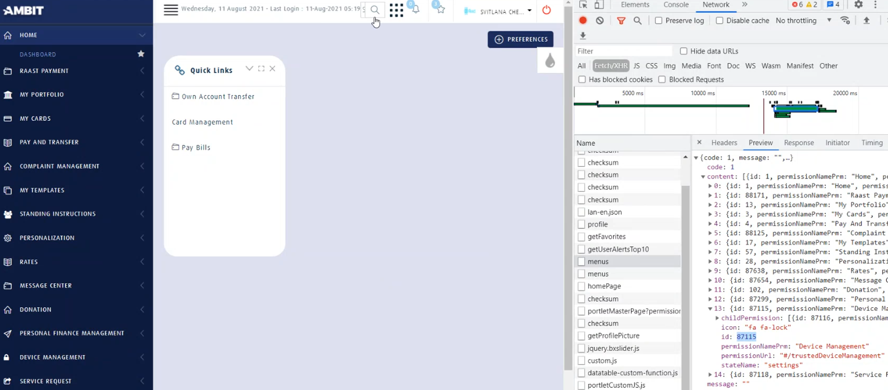

DBviewewer mai jo database hai us mai abmituser and user_device ka purpose dekhna hai pichli videos mai

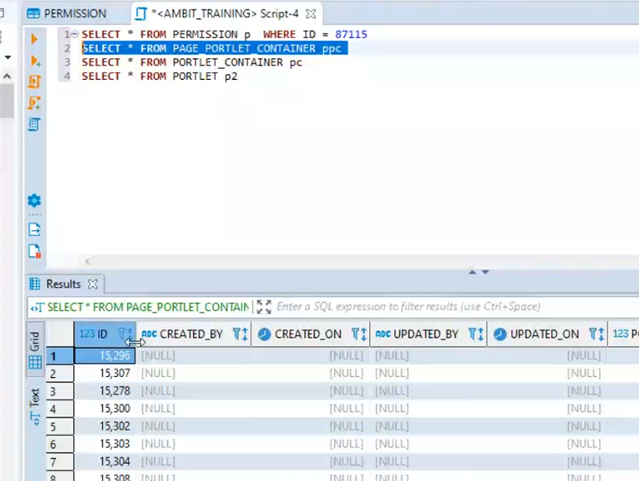

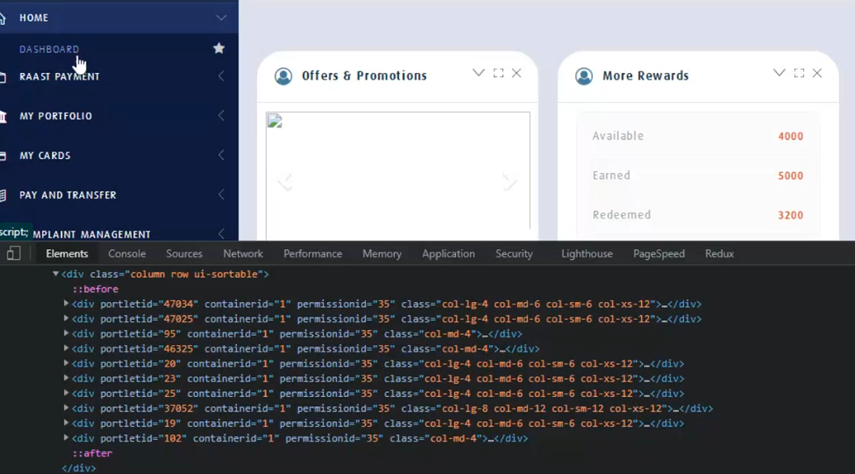

Usually hamaray pass 3 files hoti hai kisi bhi screen ko bananay k liye

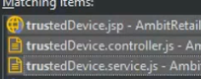

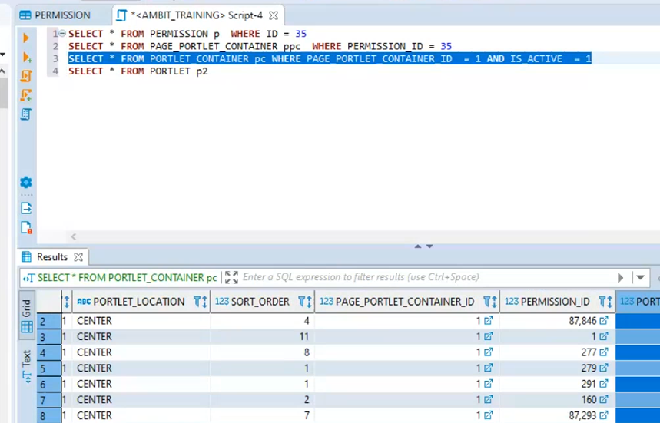

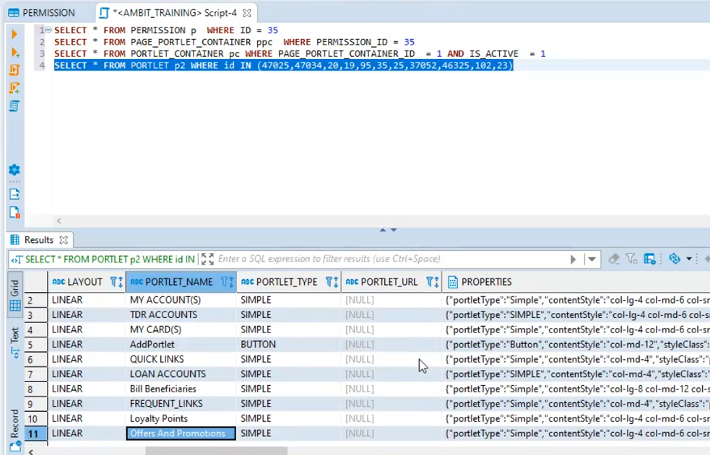

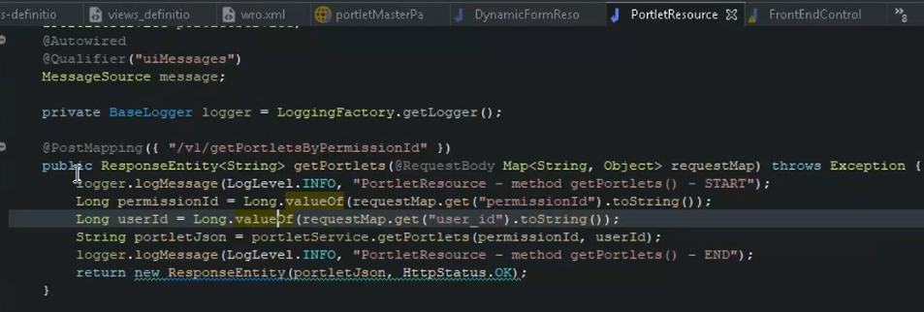

Portlet resource k andar jo getPortletByPermissionID hai wo saray portlets ki json ko return karday ga

Yai kaam hai UI Service ka jo k humne portlet preparer sai call ki hai

For ex humay new page add karna hai:

Tw portlet master page ko tw modify karne ki zaroorat nahi paray gi q wo 1 renderer hai jo already likha hoa hai

Poora jo skeleton hota hai wo portlet master page return karta hai

Portlet master page ko permission sai related cheezain chaiye hoti hai

Tw new page add karne k liye sb sai pehlay 1 permission add karengay k us menu ki permission kya hai us permission ki basis par new page banayengay ya page portlet container banayengay apna

Is page portlet container sai multiple portlet bind kardengay k aap ko kon kon sai portlet chaiye

Lets say aap nay 1 new page banaya means 1 permission banaye jiska name hai newpage

New page bananay baad 1 container banaya jiska name rakhdia new container.

New container k baad 1 portlet container banaya jis k andar aap nay apni permission ko or apne page portlet container ko bind kia or sath mai portlet id bind ki k is saari permission par konsa portlet mujood hoga

Phr us k baad 1 poray portlet ki entry ki database mai jis sai aap k pass poora 1 portlet bangaya.

Phr jab aap us permission par click karengay tw wo saari queries laga kar portlet master page ko utha kar lekar ayega

Assume kartay hai aap nay koe page banaya hi nahi hai tw us scenario mai portlet master page khali page show karday ga.

Is k andar humay further permission deni parti hai for ex group and channel parmission etc.

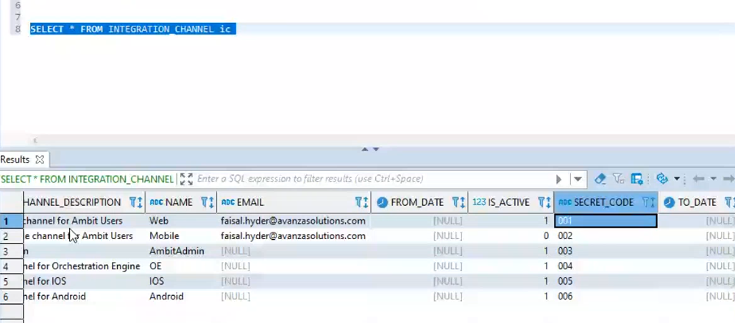

Hamaray pass permission itnay types ki hoti hai

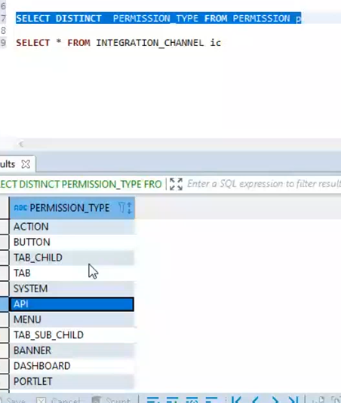

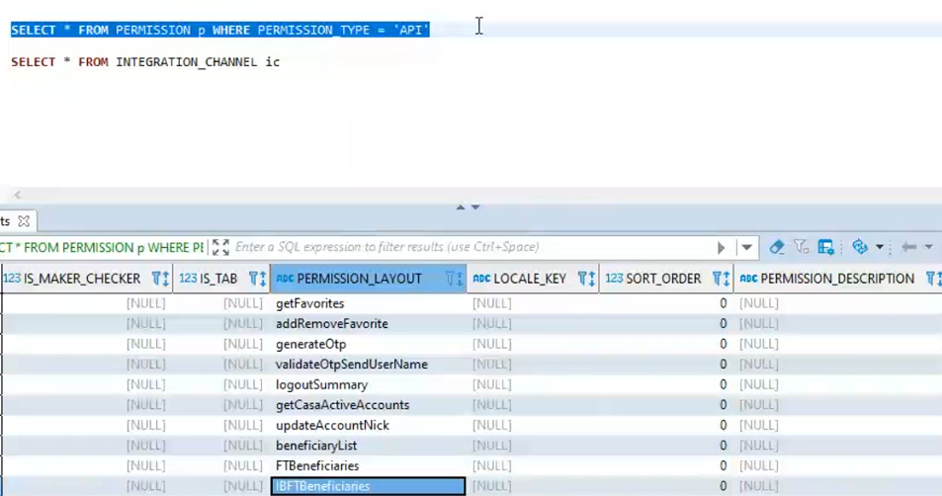

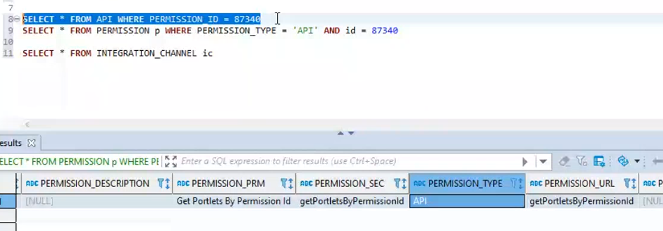

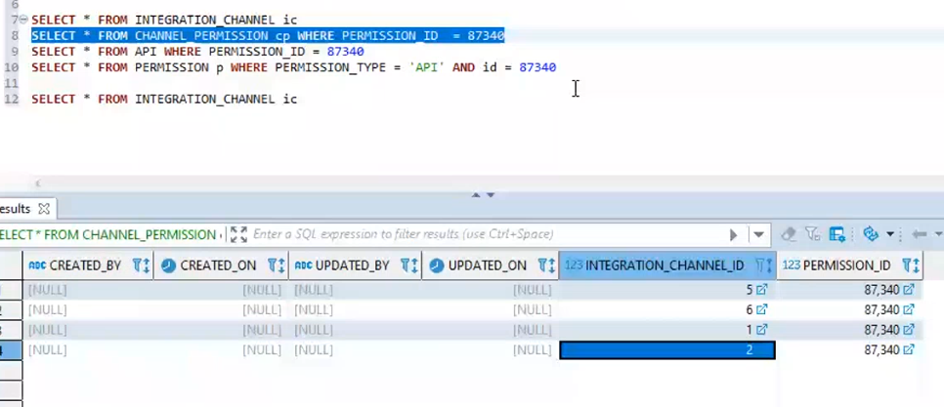

Ab agar kisi permission ko band karna hai tw channel permission mai jakar delete kardengay.

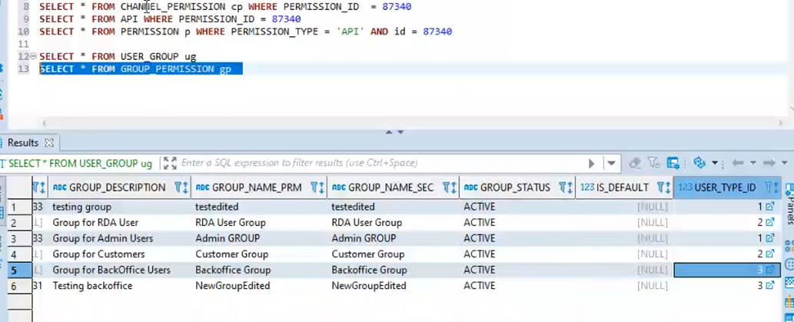

Humne 3 level banaye hoa hai request ko filter karne k

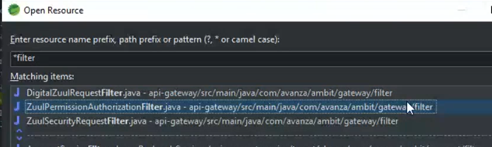

Sb sai pehlay konsa filter use hoga wo define hota hai filter order ki base par

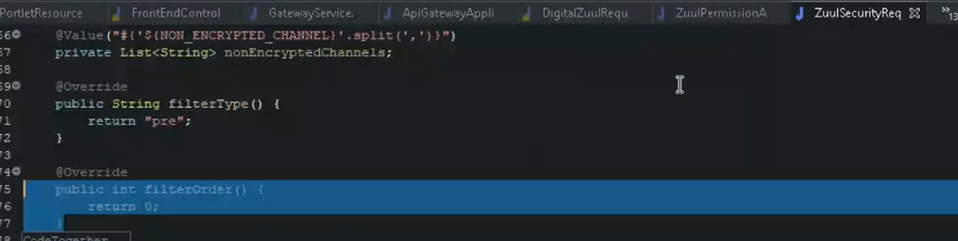

Jaise yaha par filter order 0 hai tw iski priority sb sai high hai

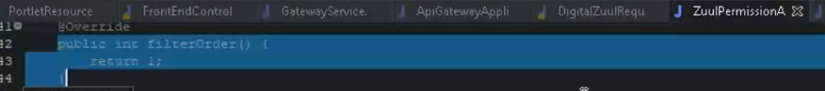

Second step par yai run hoga

Zul sercurity jo hai wo request jo arahi hai unki logging kar raha hai or check kar raha hai kya yai non ecrypted channel sai request arahi hai agar arahi hai tw isay agay Janay dain

Agar check sum enabled hai tw validate karay

Agar encryption enabled hai tw decrypt kar k reponse dain

**Dynamic Forms**

service request jo hai wo saari dynamic form sai drive horahi

dynamic form.jsp mai wo id check kar k loaddynamicfomm() ko inialize karti hai

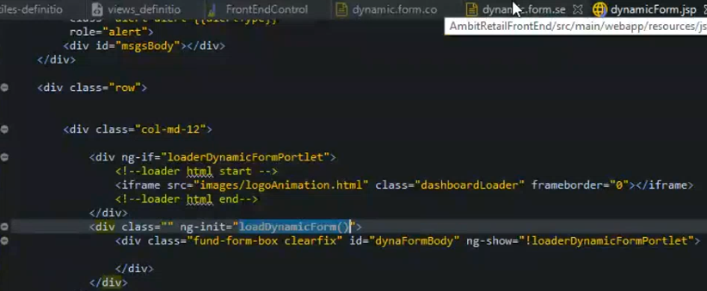

yai saara kaam web server sai nahi aap server sai horaha hai

loaddyamic form ka matlab yai hai k tile to load hogaya hai ab is k actual form ko load karna hai

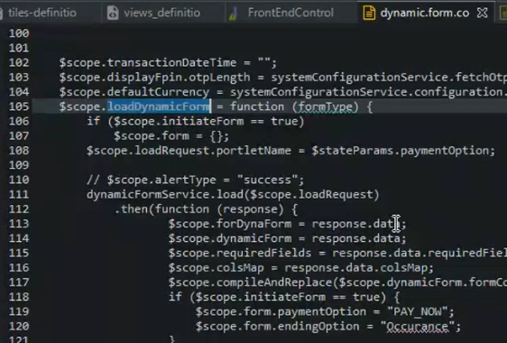

jab load request ki API ko call karengay us k peechay 1 API call horahi hogi uska Naam hoga Dynamic form create.

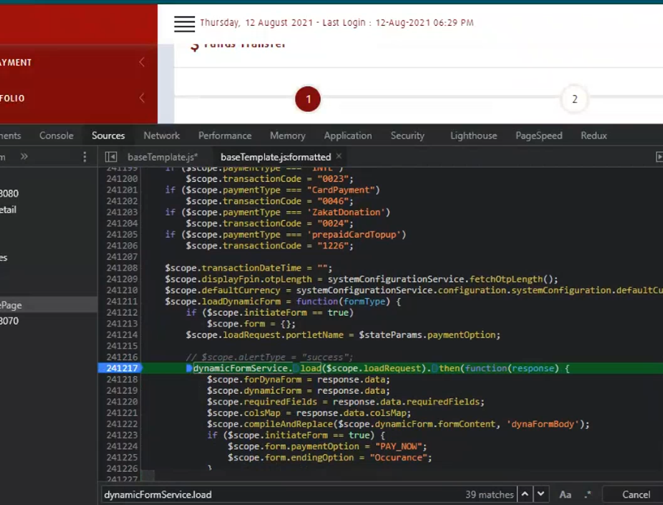

Yai keh raha hai k portlet name FT return kardo

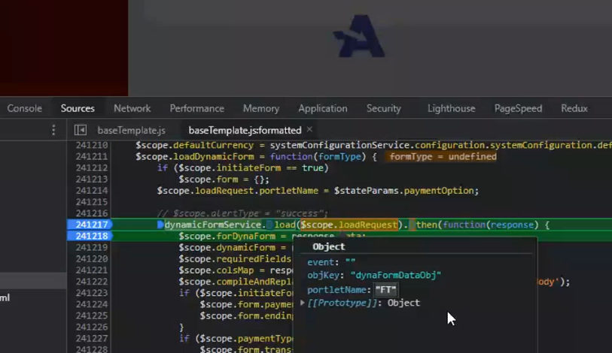

Phr hum dekhengay k response mai kya milta hai jab hamare pass call gaye tw dynamic form create ki gaye

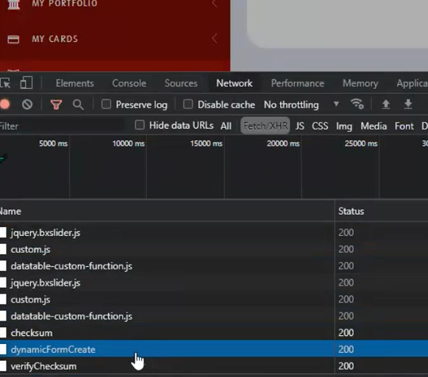

yai saray form jo services mai hai wo saray form porlets.xml mai mojood hai

humnay is k liye 1 engine likha hoa hai porlets.xml ki base par un files ko rendor karta hai

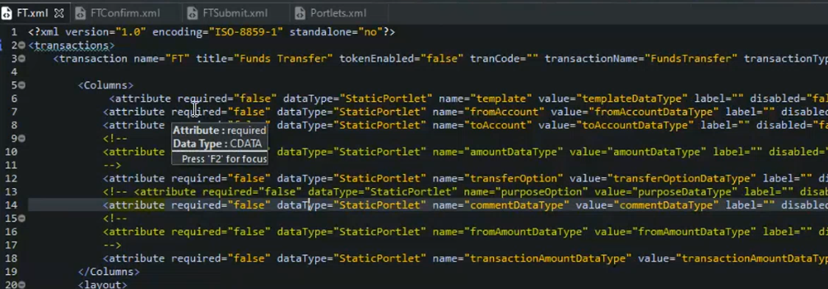

Yaha saari validation ko define kya hoa hai

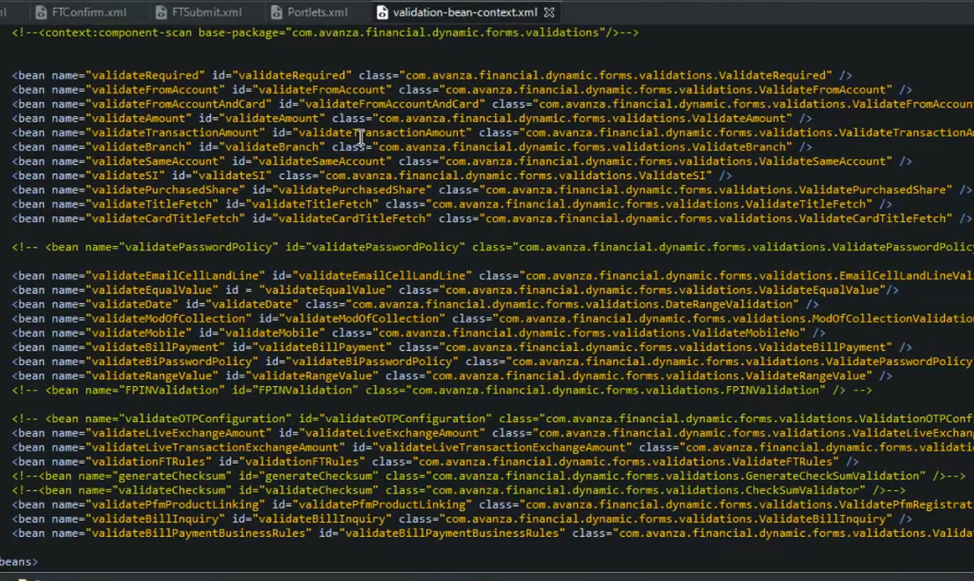

Dynamic Form Explanation – Again

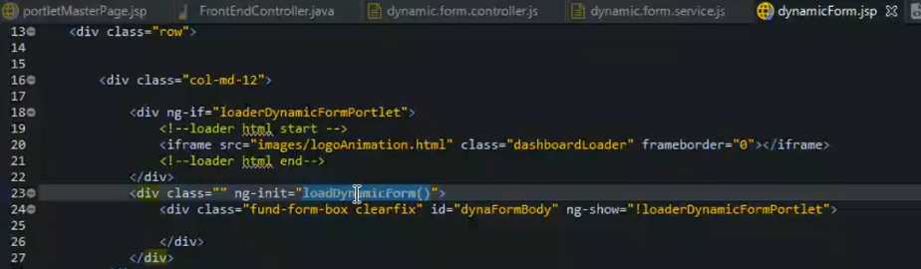

Jab hamaray pass rendor hokar saari cheezain ajati hai tw phr **loadDynamicForm** Call hota hai.

LoadDynamicForm hamaray pass **dynamicform.controller** mai mujood hota hai is k andar hum portlet name wagera bhej rahay hotay hai or iski call humay **dynamicformresource** mai arahi hoti jo k hamrai backend ki service hai.

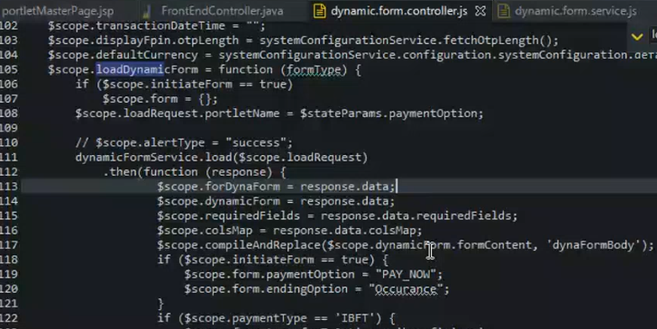

**Dynamicformresource** mai hamray pass 2 end points hotay create and process

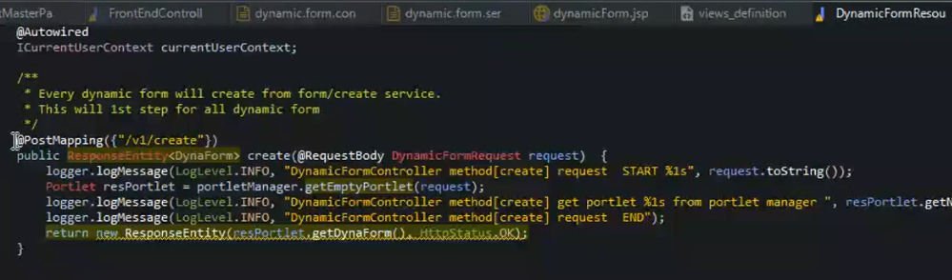

Create ka purpose yai hota hai k yai dynamic form create kar raha hota hai or portlet return kar raha hota hai

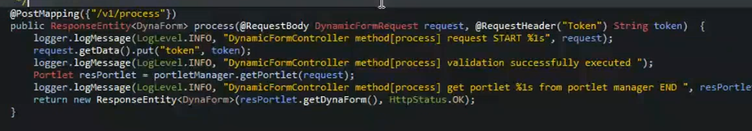

Or process ka maqsad yai hota hai k jab transitions perform horahi hoti hai us k darmiyan execution or saari cheezain hoti hai wo hamara process karta hai

**Implementation:**

Sab sai pehlay file unzip karien then phir code base main aaien aur front end aur backend ki cmd main

Command execute karien **mvn clean install –Dskiptests**

Uski bad front end ke codebase main target ke folder main se ambit.war file ko copy kar ke tomcat ke installation directory main web apps ke folder main paste kardien.

Aur backend main .jar files ko search karien aur copy karien aur unzip wale folder laike relative folder main paste kardien e.g: config-server ki folder main config-server ki jake paste kardien.

Aur last main cmd ko administrator mode main on kar ke unzip ke path main in lik kar ke tab karien command auto complete hojaiegi

then we test our service first all